**Lab Program: 07**

**Execute the fallowing queries:-**

**a. For each project, retrieve the project number, the project name, and the number of employee who work on that project.(use GROUP BY)**

**b. Retrieve the name of employees who born in the year 1990’s**

**Consider the Company database with following schema.**

**Step 1:-**

**SQL> Create table PROJECT**

**(PNO int (10) primary key,**

**PNAME varchar (20) Not Null,**

**DNO int (4) references DEPT);**

**Table created**

**Execution:-**

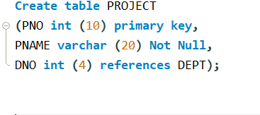

**SQL> Desc PROJECT;**

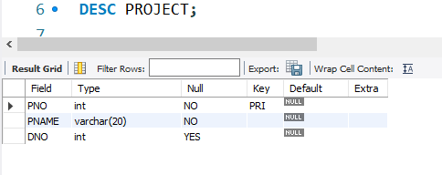

**Step 2:- WORKS_ON (ENO: int; PNUM: int; HOURS: int)**

**SQL> Create table WORKS_ON**

**(ENO int (6) REFERENCES EMP Not Null,**

**PNO int (10) REFERENCES PROJECT Not Null,**

**HOURS float (3, 1),**

**Primary key (ENO, PNO));**

**Table created**

**Execution:-**

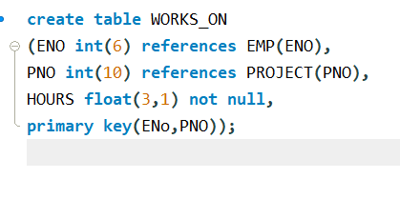

**Step 5:-**

**Insert into dept (DNO, DNAME, DLOCATION) values (2,’ACCOUNTS’, JAYANAGAR’);**

**1 rows created.**

**Insert into dept (DNO, DNAME, DLOCATION) values (4,’RESEARCH’, KENGERI’);**

**1 rows created.**

**INSERT INTO DEPT (DNO, DNAME, DLOCATION) values (5,'ADMIN','SOUTHEND');**

**1 rows created.**

**Execution:-**

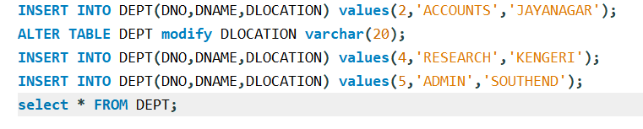

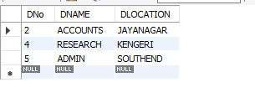

**Step 6:-**

**INSERT INTO EMP (ENO,ENAME,EBDATE,ADDRESS,GENDER,SALARY,DNO)**

**Values (1001,'ANIRUDH','1990-01-14','BANGALORE','M', 45000, 4);**

**Execution:-**

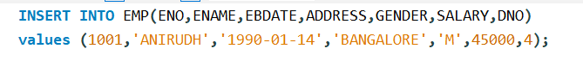

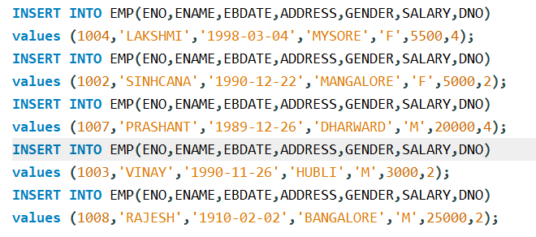

**Note: - Enter this values into the table EMP as shown below**

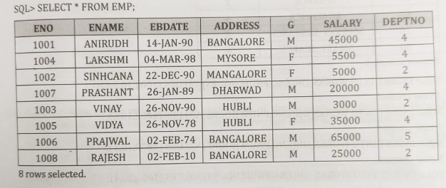

**Step 7:- INSERT INTO PROJECT (PNO, PNAME, DNO)**

**Values (20,'ERP', 5);**

**Execution:-**

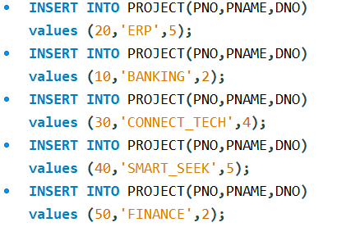

**Note: - Enter this values into the table EMP as shown below**

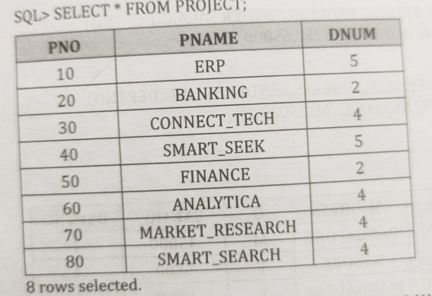

**Step 8:- INSERT INTO works_on (ENO, PNO, HOURS)**

**Values (1001, 10, 4.5);**

**Execution:-**

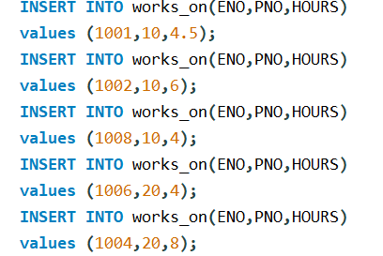

**Note: - Enter this values into the table EMP as shown below**

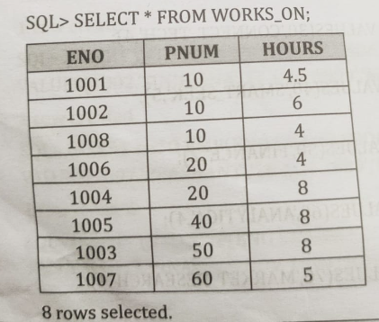

**Execute the Following Queries:**

1. **For each project, retrieve the project number, the project name, and the number of employee who work on that project.(use GROUP BY)**

**SQL> select P.PNO,P.PNAME,COUNT(*) AS "NO_OF_EMP" FROM PROJECT P,works_on W**

**where P.PNO=W.PNO GROUP BY P.PNO,P.PNAME;**

**Execution:-**

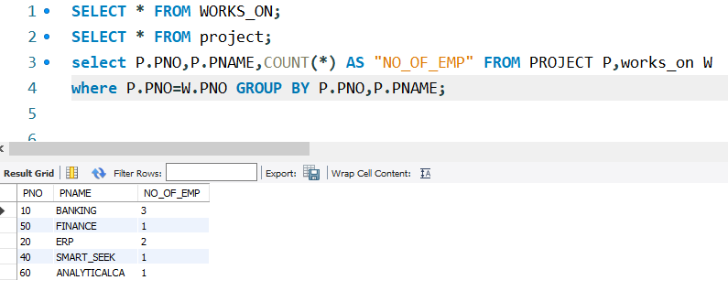

**(b Retrieve the name of employees who born in the year 1990’s.**

**SQL>** **select ENAME,EBDATE FROM EMP WHERE EBDATE LIKE '1990-%-%';**

**Execution:-**

